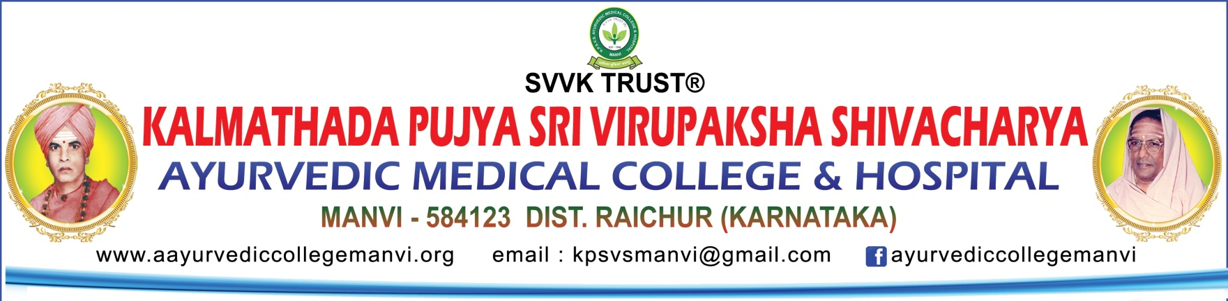

**To,**

**The Co-ordinator,**

**Karnataka State,**

**Desh ka Prakriti Pariksha Abhiyan.**

**Sub: Submission of report on DKPP Abhiyan.**

On behalf of K.P.S.V.S. Ayurvedic Medical College & Hospital, Manvi, we sincerely thank the **Ministry of AYUSH** and **NCISM** for providing us with the opportunity to participate in the **Desh ki Prakruthi Pariksha** **(DKPP)** campaign. This initiative has been a beacon of inspiration, allowing us to contribute to promoting Ayurveda on a national scale. A special thanks to the co-ordinators for their continuous guidance and support, which has enabled us to achieve this milestone.

**“Prakruthi insights, Ayurvedic Heights: 31,733 stories of health!”**

**Volunteers and Achievements:**

**Principal:** Dr.Jeevaneshwarayya

**Co-ordinator:** Dr.Shilpa Mahajan

**Student Volunteers:** 276

**Teacher Volunteers:** 31

**Total Volunteers:** 307

**Total Prakruthi Parikshan Conducted:** 31,733

**Strike Rate:** 103.36%

**Strategic Planning, innovations and Execution:**

**1. Orientation Program:**

All staff and students were oriented on the Prakruthi Pariksha App to ensure smooth data collection and accurate assessments.

**2. Team Formation:**

Volunteers were divided into teams comprising 1 faculty and 10 students, ensuring a balanced and organized approach. This created high competition between the teams.

**3. Regional Content Creation:**

All necessary materials were created in the Kannada language to improve public engagement.

**4. Awareness Videos:**

Two videos in Kannada were produced to educate and motivate the public about the campaign.

**5. Asha workers meeting:**

Asha workers were trained to create awareness of Prakruthi Pariksha in their particular areas.

**6. Comprehensive Outreach:**

Our volunteers conducted Prakruthi Pariksha in various sectors, including:

**Institute Members:** Students and staff of our institution, along with their family members and friends.

**Educational Institutions:** Engaging students and staff from nearby schools and colleges.

**Workplaces:** Employees and customers of banks, LIC offices, post offices, hypermarkets, and local shops.

**Healthcare Facilities**: Staff and patients at the Taluka Government Hospital & other private Hospitals.

**Public Services:** Police station staff, court staff, and petrol pump employees.

**Community Areas**: Door-to-door visits in local areas, nearby villages, and panchayats.

**Devotional Sites:** Devotees at temples such as Anjaneya Temple on Saturdays, Sai Baba and Raghavendra temples on Thursdays, and pilgrimage sites like Mantralaya and Panchamukhi.

**Experiences and expertise gained:**

This campaign provided an invaluable opportunity for our students and faculty to engage with diverse communities and witness the impact of Ayurveda on a national scale.

**Community Engagement:** Our volunteers reached diverse communities, conducting Prakruthi Parikshan with precision and compassion.

**Skill Development:** Students gained hands-on experience in understanding prakruthi (constitution) assessment, enhancing their diagnostic capabilities and confidence.

**Awareness Drives:** We organized awareness sessions, Rally and educational programs to emphasize the significance of understanding individual prakruthi for preventive healthcare.

**Conclusion:**

We take immense pride in being part of this transformative initiative. The DKPP campaign has been an enriching journey, allowing us to contribute to public health and the promotion of Ayurveda across the nation. We remain committed to working with renewed enthusiasm in the upcoming phases of this campaign.

|  |  |  |  |
| --- | --- | --- | --- |
| **HIGHEST NO. OF PRAKRUTHI PARIKSHA ASSESSMENT FROM OUR COLLEGE (AYU0076)** | | | |
| **Teaching staff:**    Dr.M Pruthvi Kumar  Teacher code: AYKC00338 | Total No. of Prakruthi Pariksha – 2559 | D:\College campus photos and video\teaching staff Passport size photo\Pruthvi-M.jpg | F:\Veerayya\Shilpa\Prakruti Pariksha\Report\WhatsApp Image 2025-01-02 at 6.58.07 PM.jpeg |
| **Student:**  Vontari Manichandana  Batch: 2019-20 | Total No. of Prakruthi Pariksha – 355 | F:\Veerayya\Shilpa\Prakruti Pariksha\Report\WhatsApp Image 2025-01-02 at 7.09.18 PM.jpeg | F:\Veerayya\Shilpa\Prakruti Pariksha\Report\WhatsApp Image 2025-01-02 at 6.56.48 PM.jpeg |

Thank you

Regards,

**Dr.Shilpa Mahajan**

DKPP Co-ordinator

KPSVS AMC & H, Manvi

GLIMPSES OF DKPP ABHIYAN

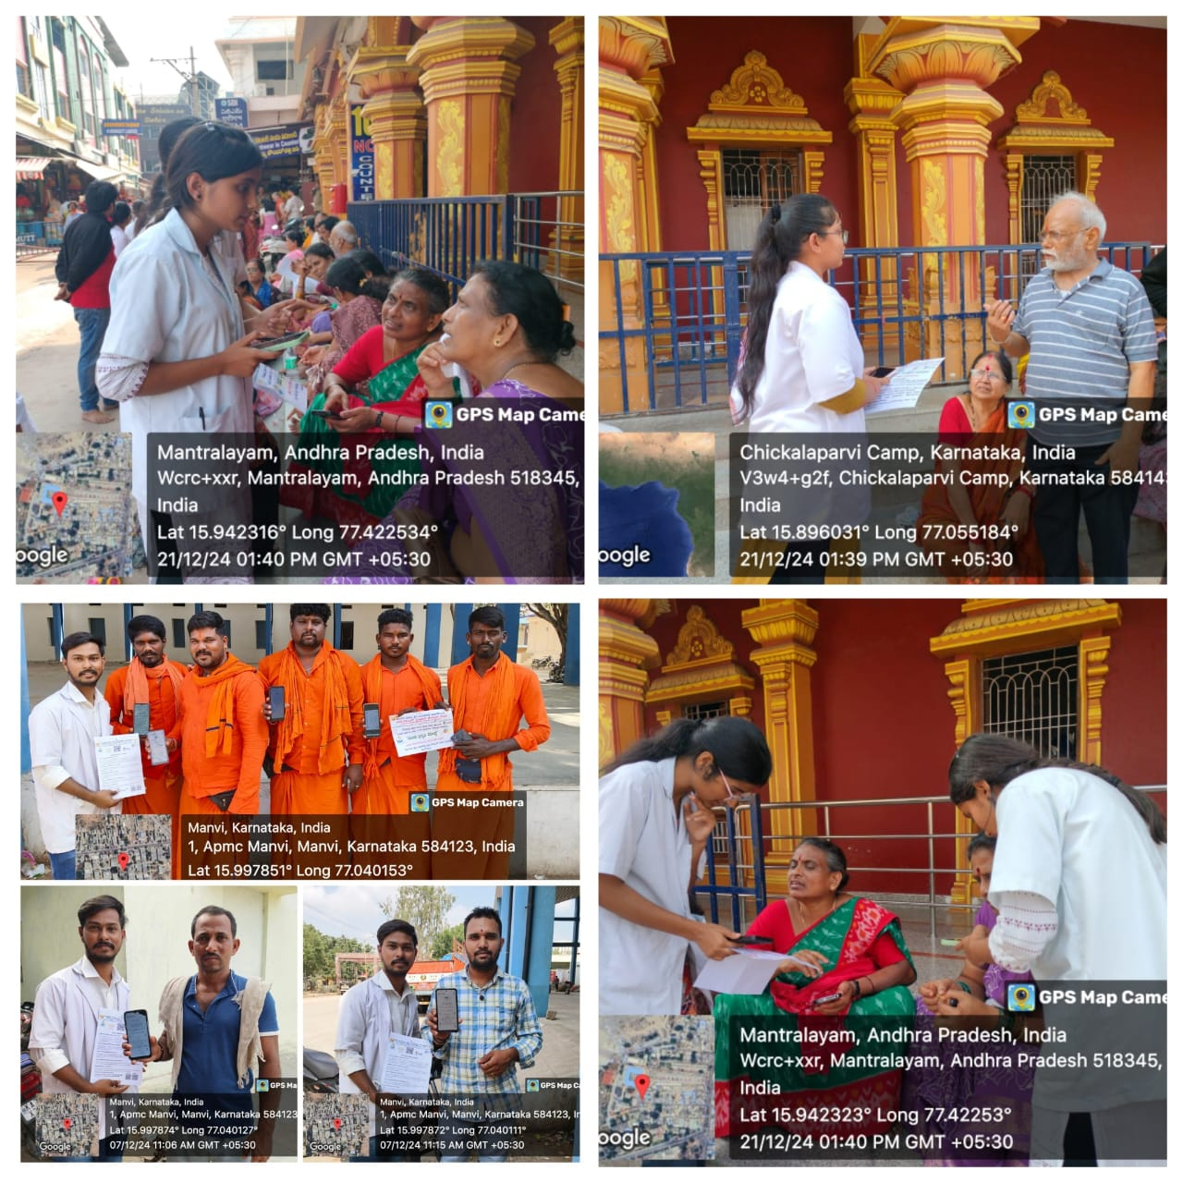

“**Temple visits redefined:** Spiritual cleaning with Prakruti Pariksha insights”.

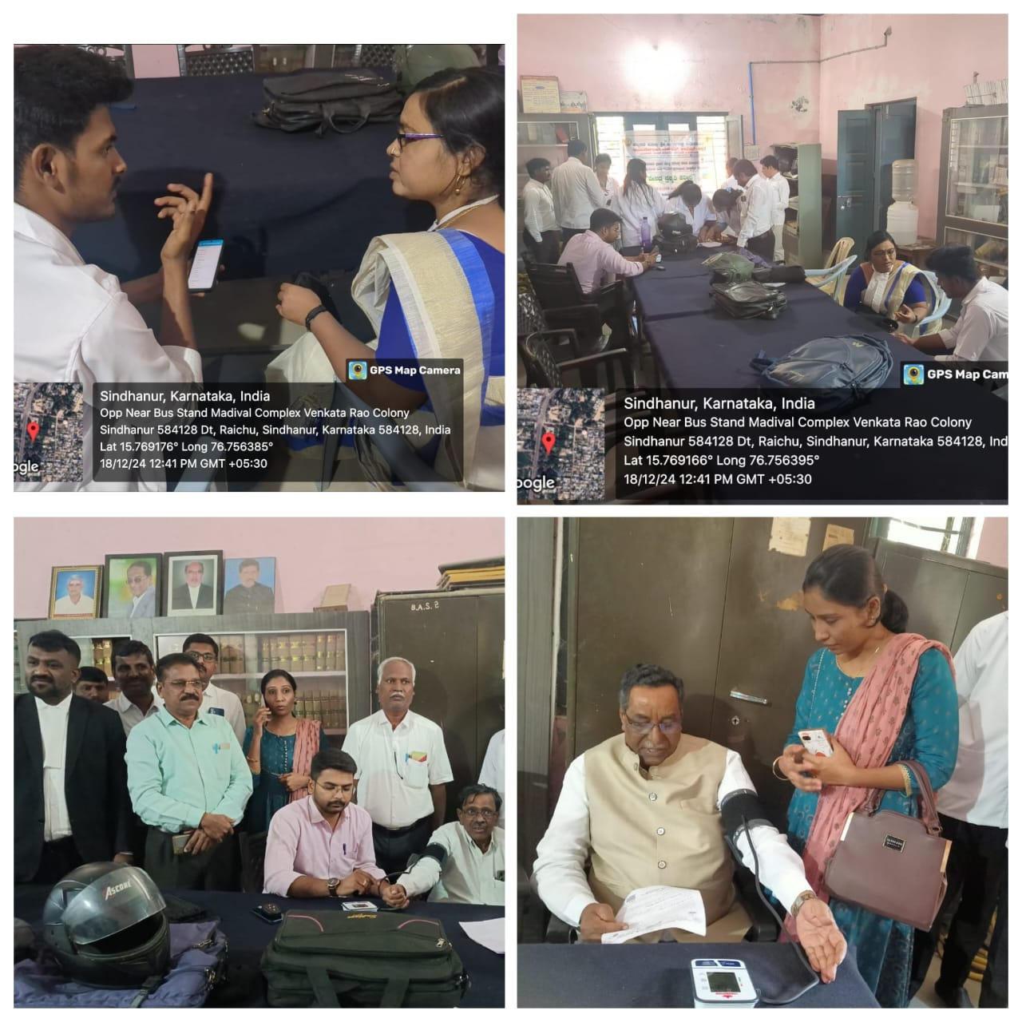

“Justice for Health: Prakruti Pariksha at the court premise”.

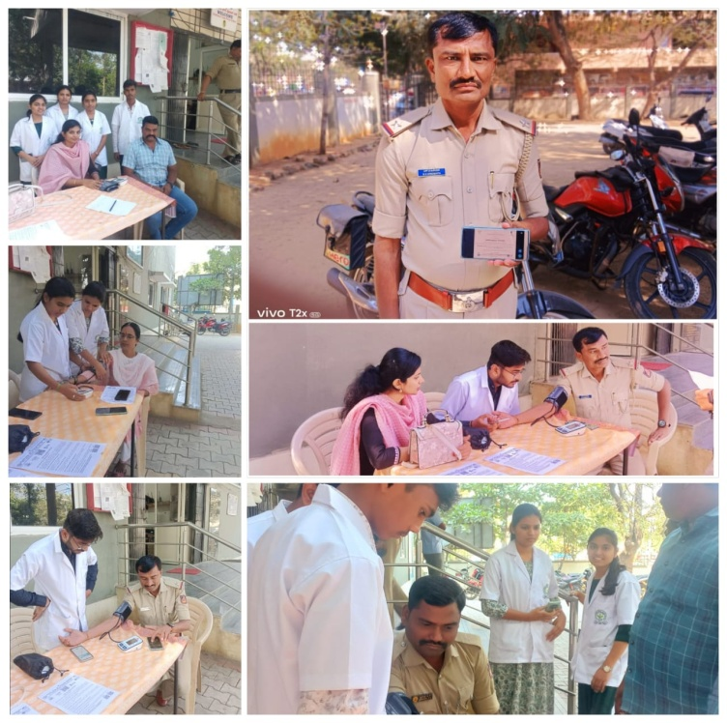

“Wellness in service: Discovering Prakruti for our protectors of peace”.

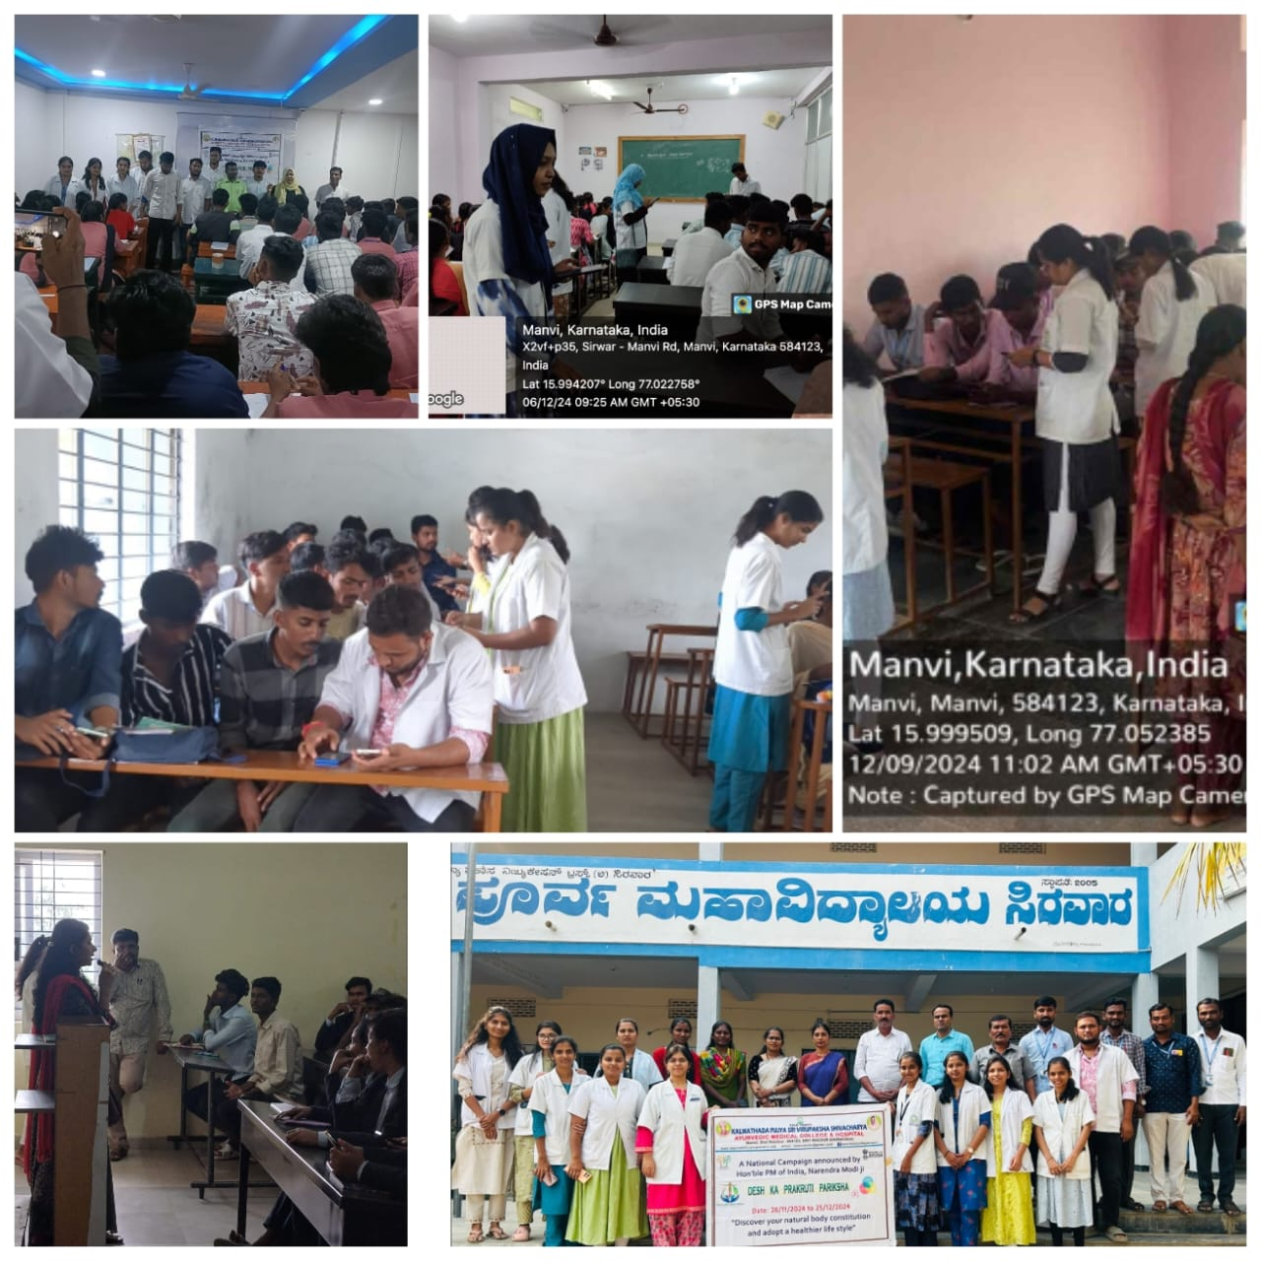

“Ayurveda meets academia: empowering future generation with insights into their Prakruti”.

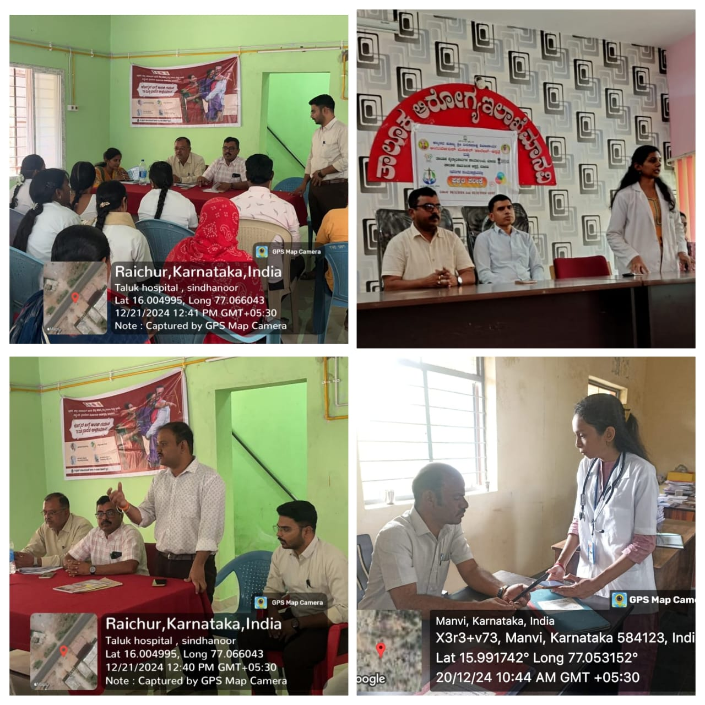

“Community Health uplifted with Prakruti Pariksha at Taluka Govt. Hospital”

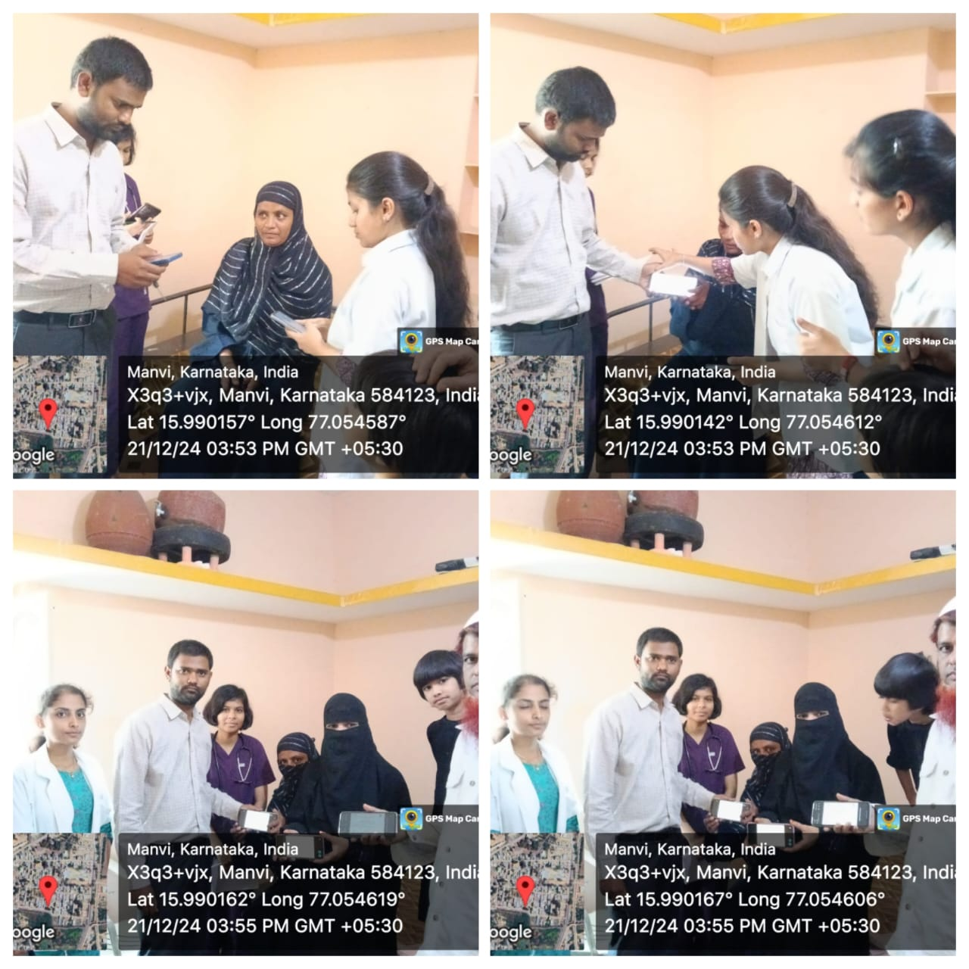

“Prakruti Pariksha for community’s women at the Madrassa”

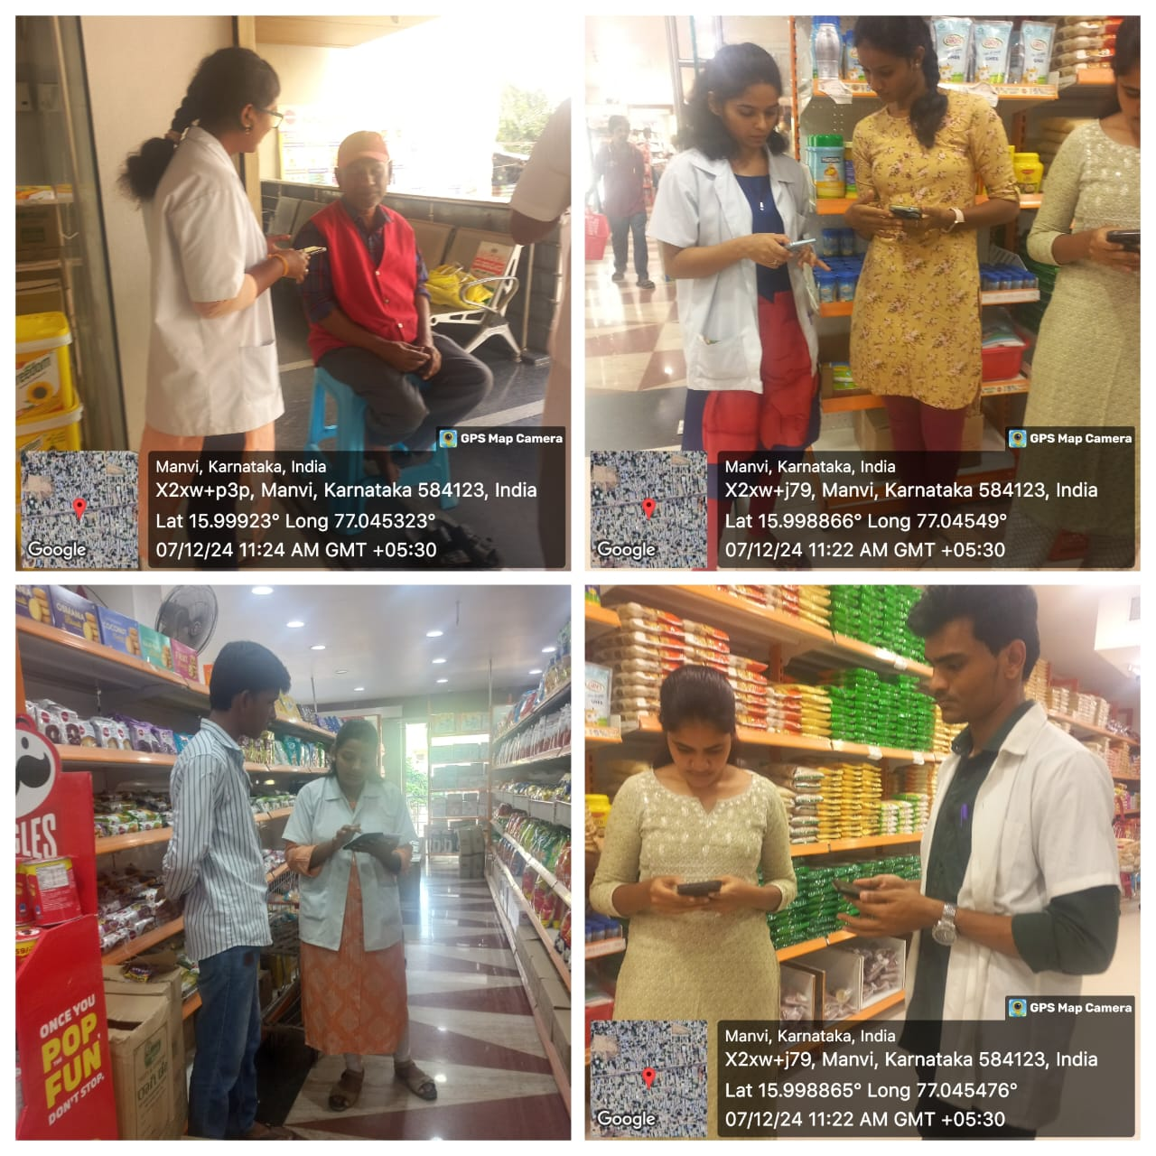

“Bringing Ayurveda to the shopping cart- Prakruti Pariksha at Hypermarket”

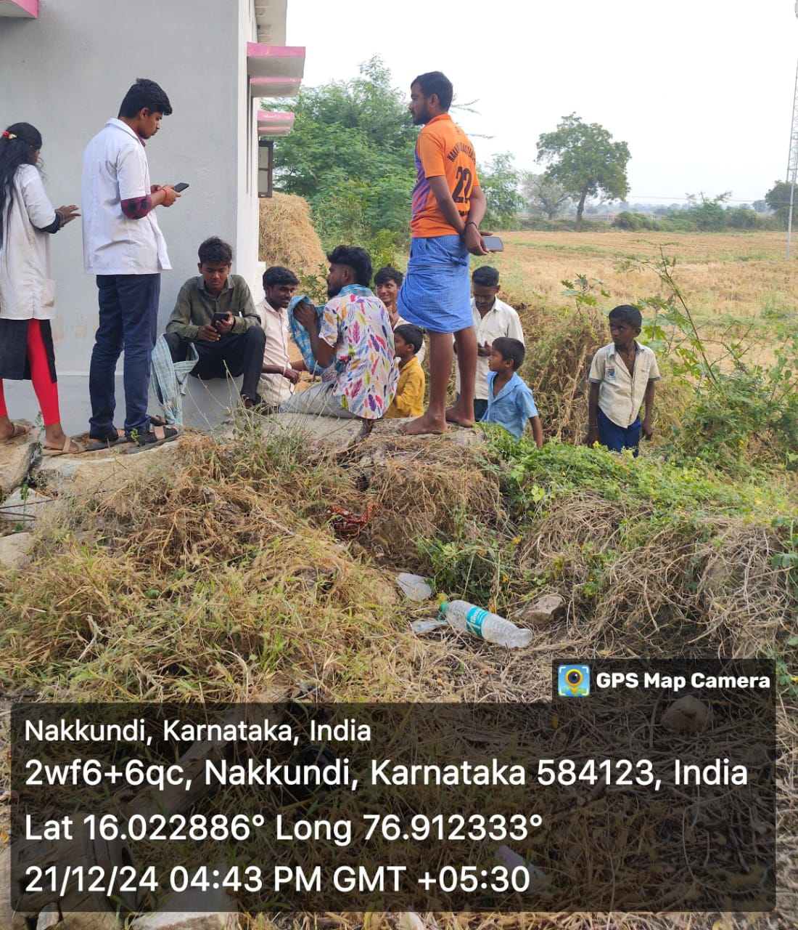

“Sowing the seeds of Health alongside crops- Ayurveda meets farmer’s fields”

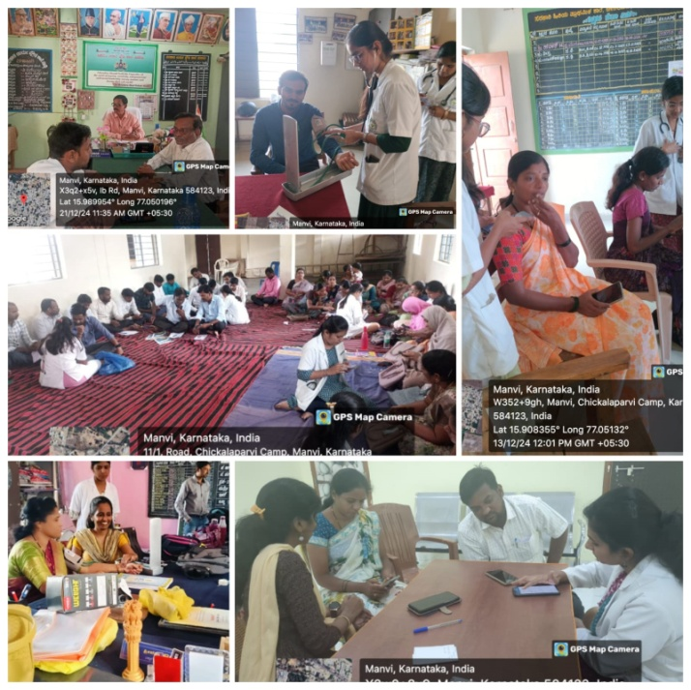

"Empowering educators with the wisdom of Ayurveda – Prakruthi Pariksha for teachers."

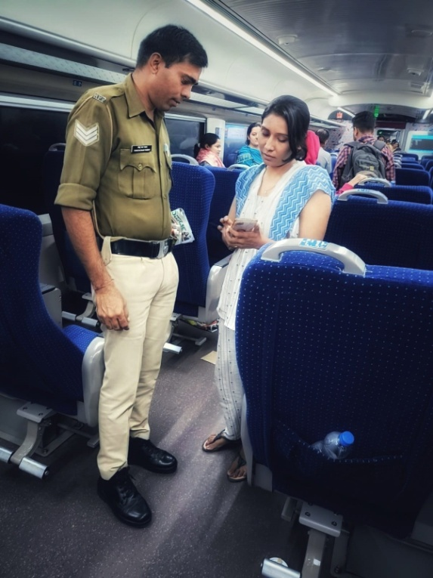

“On my journey to hometown, Ayurveda meets security- Prakruthi Pariksha for RPF On Vande Bharat Express”.

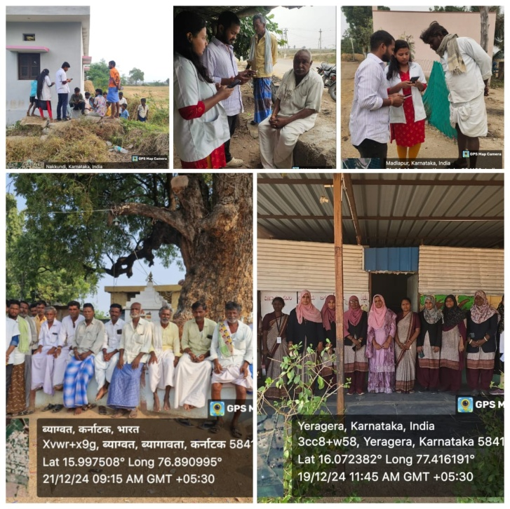

“Holistic health for every villager- Prakruthi Pariksha touches rural lives”.

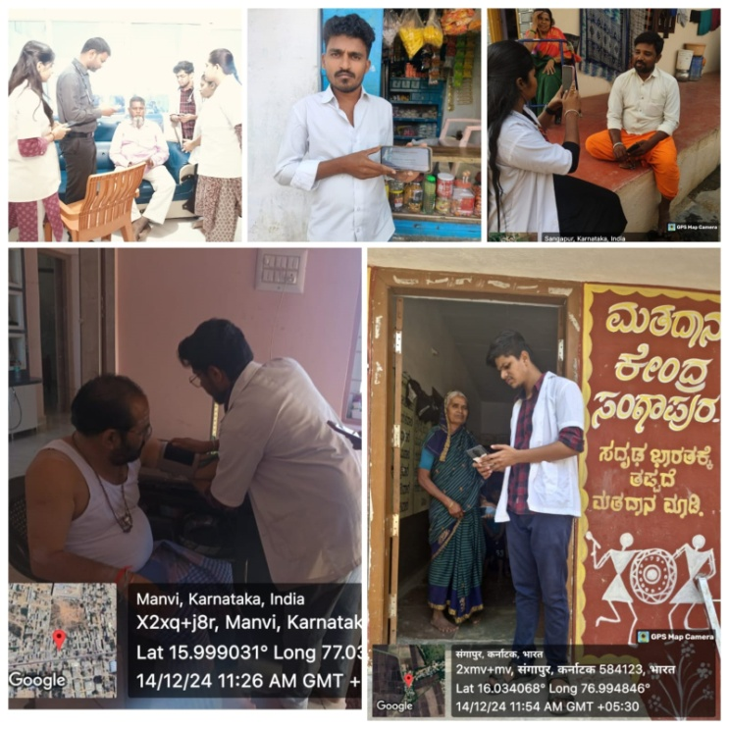

“Opening doors to wellness- Ghar Ghar Prakruthi Parikshan”.