11.04.2024

Report on Brainstorming session on world Parkinson's disease day from kayachikitsa department:

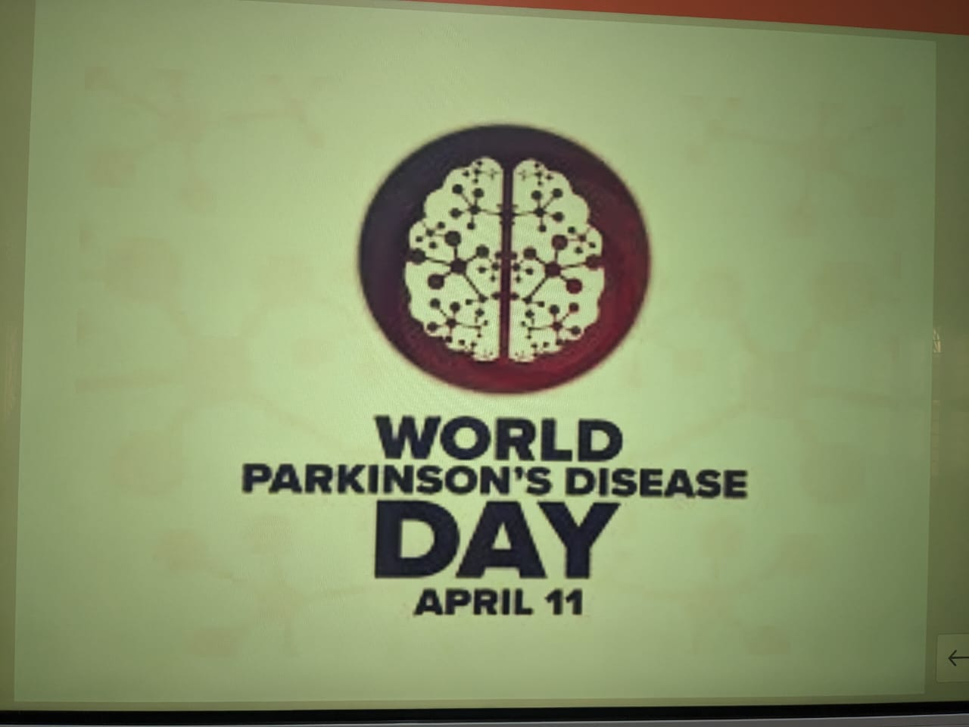From the department of kayachikitsa Dr. Sharanamma Ast.prof. has been conducted the Brainstorming session on world Parkinson's disease day on 11th April 2024 for 4th year and 1st phase BAMS students of KPSVS AMC& H. Manvi Raichur.

