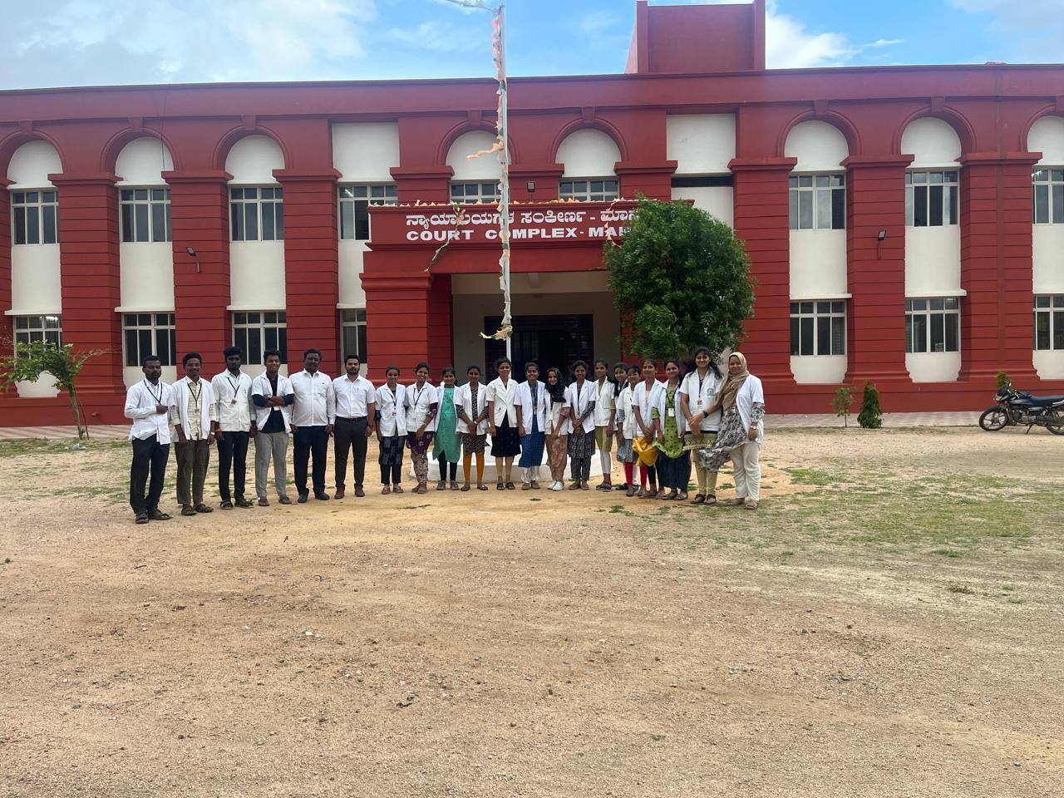**Court visit as per NCISM curriculum for 2nd Phase professional (27/6/2024 & 28/06/2024)**

