**1/07/2025 : A free medical camp was held at yaddaladoddi village as a part of ‘’Doctor’s day” in association with CSF(Central state form)Javalgera Raichuru (dist).**

The camp was inaugurated by Shri Mahalinga swamiji, Suvarnagiri matha, yaddaladoddi

in the presence of Shri Shatasthala brahmi Virupaksha Panditharadhya Swamiji, Kalmatha, Manvi.

The team of consultants are

Dr. Jeevneshwarayya, Professor & HOD, Dept of Rasashastra, Dr. Shivaraj Odeyar, Professor & HOD, Dept of Dravyaguna,

Dr. Mamatha ,Deputy medical officer, Dr.Sunitha, Professor & HOD Dept of Agada tantra, Dr. Vikramaditya, Reader, Dept of Panchakarma,

Dr. Visheshwarayya Math , Reader, Dept of Rachana shareera, Dr. Hampamma, Reader & HOD,Dept of Kayachikitsa,

Dr. Shilpa, Reader, Dept of Dravyaguna,

Dr Shrikanth Kulkarni ,Reader, Dept of Shalakya tantra, Dr. Sharanamma, Asst.professor,dept of Kayachikitsa, Dr.Pramod M, Ass.professor, Dept of Agada tantra, Dr. Samantri Jyoti, Asst.professor, Dept of Samhitha,

Dr.Abuzuber, Asst. professor, Dept of Panchakarma, Dr.Priyanka,Asst.professor, Dept of Swasthavritta, Dr. Mounika, Asst.professor, Dept of Prasuti tantra,

Dr.Anjum parveen, Asst.professor, Dept of Shalya tantra, Dr. Varsha Kulkarni, Asst.professor, Dept of Kayachikitsa,

Dr.Anupama, Asst.professor, Dept of Shalakya. The camp was supported by UG students and Hospital staff.

The camp was beneficial for 320 people and most of the complaints were related to knee joint pain, low back pain,Nutritional anemia, Skin diseases, Eye diseases and Metabolic diseases.

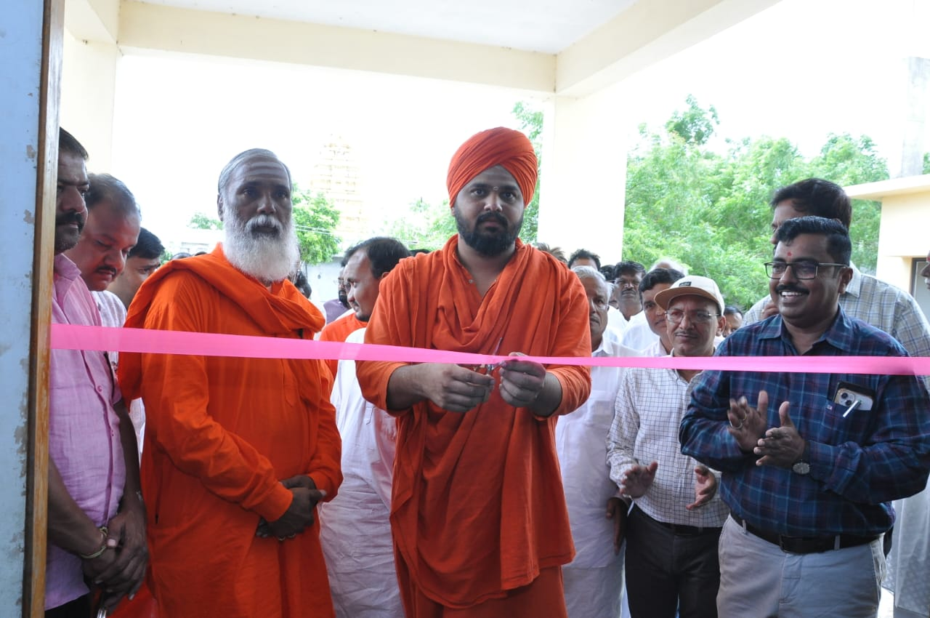Patients of village expressed their gratitude to the Institution, Doctors and students for their service.

